MATH ML EDITOR IN FLEX

Abstract:

Mathematical mark up language is a set of specifications proposed by the World Wide Web Consortium for the display of mathematical equations on Web.
MathML is an XML specification which enables native rendering of mathematical formulas by the browser.
It aims at integrating mathematical formulae into World Wide Web documents. It is a recommendation of the W3C math working group.

History of MathML:
The mark up language HTML has a large variety of tags .But there are no explicit tags for the rendering mathematical expressions.As a result,to embed math equations,Authors have resorted to embedding images of equations. Snap shots of equations taken from other packages and saved in GIF format - into technical documents which have a mathematical or scientific content.
Embedding of images in Web Pages is costly interms of storage space.To overcome this,.,The MathML specification is put forth which helps browsers understand ,the Math Mark up language

Type of MathML:

Presentation MathML:
Presentation MathML focuses on the display of the equation
rather on the meaning of the Equation.The Components of Presentation math ml constitutes 30 elements and 50 attributes.
Element tags begin with ‘m’ and include token elements.
<mi>x</mi> - identifiers; <mo>+</mo> - operators; <mn>2</mn> - number. Tokens are combined using layout elements which include: <mrow> - a row; <msup> - superscripts; mfrac - fractions.
Attributes mainly control the fine details of the presentation.

Content MathML :
Content MathML focuses on the sematic meaning of the equation.Wherein there is an <apply>tag which specifies tht a particular operator is applied to the succeeding elements.
For Example
For Eg:<apply>Integral
Here Integral is applied to all the elements enclosed.
Research on Existing Mathematical Templates:

Simple example of MathML
x² + 4x + 4 =0
and below are two ways that this can be represented, first using presentational tags, then using semantic tags. The presentational tags generally start with "m" and then use "o" for operator "i" for identifier "n" for number, and so on. The "mrow" tags indicate organization into horizontal groups.
<mrow>
<mrow>
<msup> <mi>x</mi> <mn>2</mn> </msup> <mo>+</mo>
<mrow>
<mn>4</mn>
<mo>&InvisibleTimes;</mo>
<mi>x</mi>
</mrow>
<mo>+</mo>
<mn>4</mn>
</mrow>
<mo>=</mo>
<mn>0</mn>
</mrow>

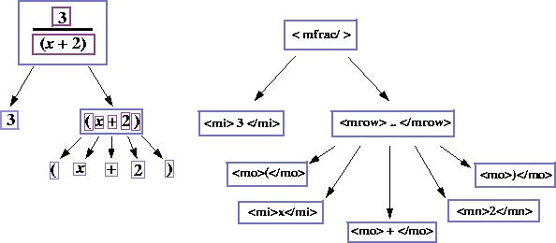

MathML to Equation:
This refers to the process of converting the MathML code to a graphical display of Math Formula.

The Math ML code is parsed as an XML ,and each of the element equation is rendered visually.

Mathematical TypeSetting

